Gregory Enloe Address
Center & Defender City, State, Zip
Class of 2005 Hanford High School Phone
Central Valley Water Polo – CAP 9 Email
Height: 6’5” | Weight: 215 | Wing Span: 6’6’ | DOB: 02/17/87
GPA: 4.28 | SAT: 1280
100 Free: 48.9 | 100 Breast 1:02.15 | 200 IM 2:01.54
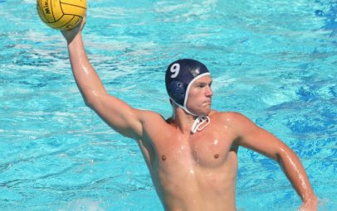
Video footage on Youtube – Name
Url:
Academic Achievements
- Accumulative Weighted GPA for Grades 9-11: 4.28
- Accumulative Un-Weighted GPA for Grades 9-11: IDK
- SAT – 1280/1600, SAT II Subject Tests: Chem - 680, Math 2 - 690
- ACT – Did not take
- AP Exams – Anything with 4 or higher
- 7th Highest GPA of 415 Hanford High Students

Athletic Achievements
2005
- Olympic Development Program Central Zone Selection - Center
- High School All-American 8th Team
- CIF Central Section Division 2 – 1st Team
- West Yosemite League Water Polo MVP
- Hanford High School Most Valuable Defensive Player
- Varsity Basketball starting Center
- Varsity Swimming sprints –
2004
- Varsity Water Polo starting Center since Freshman Year
- Hanford High School Water Polo Most Inspirational
- Varsity Basketball starting Center – Grit, Grind, and Hustle Award
- Varsity Swimming MVP and Effort Award

Water Polo Stats
High School Senior Season
- XXX Goals
- XXX Assists
- XXX Drawn EJ
- XXX Sprints
- XXX Steals
- XXX Field Blocks
- (Put what is impressive)

Coaches
Reference School - Name
Phone
Email
you can have up to three

